[TPP-10200] 2052A Create SQL objects needed to support File Creation - Enterprise Jira

When SSISLoadActiveLOCCollateralData stored procedure is executed. Then Active locs data is loaded in EActiveLOCCollateralData Table.
Result set : Existing report ReportLetterOfCreditActive
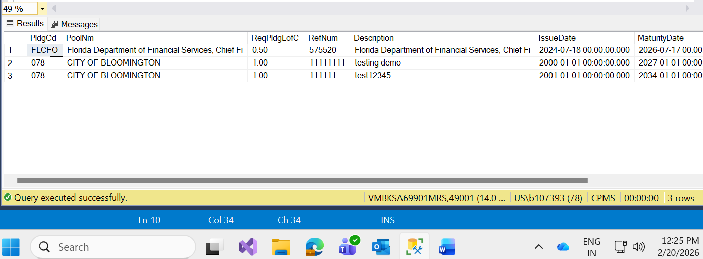
ResultSet: run SSISLoadActiveLOCCollateralData stored procedure
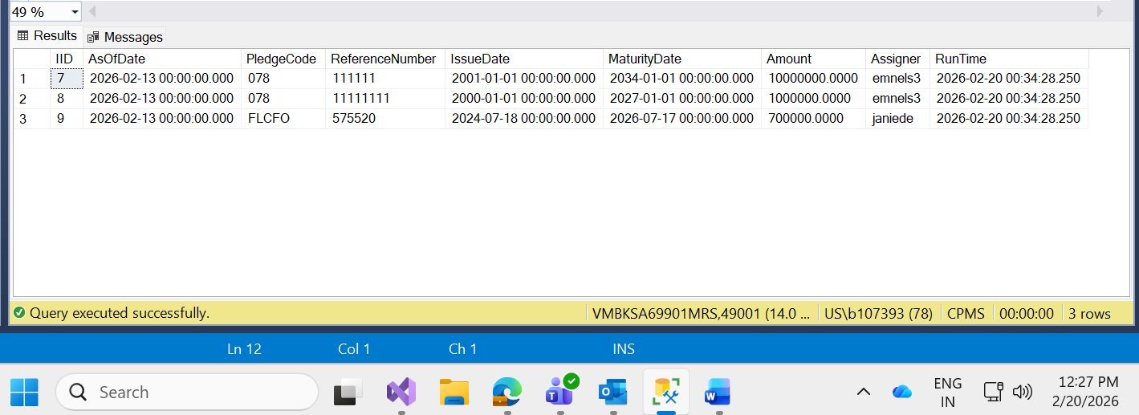

Resultset : Run SSISActiveLOCCollateral
